COMPLIANCE STATEMENT:
Percutaneous renal biopsies are the gold standard for the diagnosis and subsequent treatment of renal diseases and transplant kidney pathologies. It is important for a trained professional to assess the adequacy of the biopsy as needed per the clinician request to confirm adequate tissue is collected and divided into the proper media for all modalities to aid in a successful diagnosis.
Adequacy Assessment Training
Pathologists’ Assistant’s (PA) and Gross Room Technologists (GRT) are trained through accompanying an experienced staff member trained to perform the adequacy assessments. The trainee begins the first two times as an observer and watches how the staff member performs the steps of the procedure and what responses to give the clinicians conducting the biopsy. Ideally, one will be in Interventional Radiology and the other at the bedside to see both environments. The trainee will look at the biopsies under the microscope and identify the tissue type and if there are adequate glomeruli given the size of the cortical region of the core(s) and relay this information to the clinicians.
After adequate observation the roles will switch, and the trainee will get the biopsy and assess for correct tissue type and adequacy with the staff member there to confirm and offer additional support and guidance. This will include both IR and bedside and then once signed off will enter the rotation of being able to perform assessments independently.
Sign off on this task is accomplished by having the gross room supervisor or designee accompany the trainee on a procedure and confirm adequate cortex was obtained and divided appropriately. The pathologist reviewing the case will confirm adequacy and correct tissue and give feedback based on their review of the case. A training document will be signed and put in the staff members’ employee file and any issues will be communicated and additional training performed (if needed) as they are found once trained.
If an appropriate level of competence is not achieved following this training, the trainee may be placed on a process improvement plan for this task until competence is achieved at the discretion of the lab supervisor and renal attending pathologist.
Procedure for IR and Bedside
- The room calls and lets you know a procedure is eminent and its location.
- Confirm you are in the proper clothing/ know what PPE to wear (hospital scrubs/coat no outside clothes).
  - Interventional Radiology (IR)= Hospital scrubs, closed toe footwear, hairnet and surgical mask and gloves for procedure.
  - Bedside= Hospital scrubs and gloves for procedure.
  - ALL locations= Confirm no special precautions need to be made.
- Collect the three media containers in a biohazard bag (and a renal biopsy requisition if at bedside) and quickly ensure that the cart is stocked with supplies.
- When the room calls and says it is time to start, take the cart to the room.
- While they are setting up, plug in the microscope and set up the stage with a drop of phosphate buffered saline, label the containers with patient stickers, get the order from the nurse, and open a blade to be ready for when the cores are ready.
  - If at bedside, the patient labels may be in a patient folder and can be found at completion of the biopsy, but do not leave that general area with unlabeled containers.
- Participate in the time out by stopping what you are doing and listening to the nurse and confirming the name on the requisition and the patient labels to the one they say and on the white board.
- The clinician will take the first core biopsy and pass to you off the sterile field on a plastic apparatus or another apparatus. Take care not to touch the sterile field or the clinician’s gloves.
- Using the tip of the blade, roll the biopsy off the apparatus and onto the slide/wax to assess for diagnosis. Try to not manipulate the biopsy with forceps as it is a delicate tissue, and the forceps can introduce artifact or damage the specimen.
- Using the microscope, confirm the tissue type: cortex, medulla, blood, muscle, fat, connective tissue.
- Communicate the percentages of tissue type to the clinician (i.e., “I see 50 % cortex and 50% medulla”) and if an additional core will be needed (have less than ~3 mm of cortex)
  - If there is an issue arising where additional cores cannot be taken due to safety concerns for the patient or other considerations the tissue obtained can be put in a sterile container and brought to the lab to submit following consultation with the renal attending on service.
  - The attending on service can be called from the procedure room to consult to triage the tissue as to the best processing modalities.
  - If you encounter any trouble identifying tissue types or adequacy, you are encouraged to call the lab ((720) 848-4653) and ask for the supervisor, a Pathologists’ Assistant, or attending to assist.
- The amount of tissue needed is highly variable based on clinical presentation, test results, and differential diagnosis. Using these general guidelines will ensure all bases are covered.
  - If glomeruli are visualized:
    - 1-2 glomeruli for electron microscopy
    - ~6 glomeruli for immunofluorescence
    - >8 glomeruli for light microscopy
  - If glomeruli are not visualized:
    - 2 mm of cortex for electron microscopy
    - 6-8 mm of cortex for immunofluorescence
    - 12 mm of cortex for light microscopy
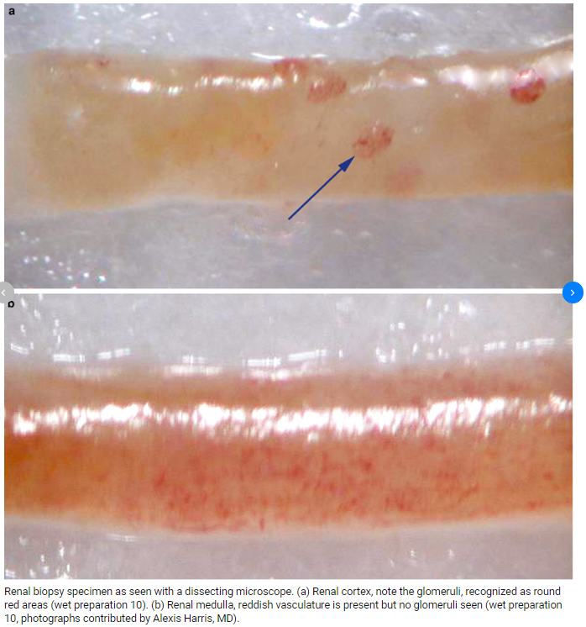
- Splitting of the cores should not happen until all tissues have been collected. They can stay on the slide or wax with phosphate buffered saline to avoid drying out.
- The tissues can be split into the proper media containers following two modalities depending on the condition of the kidney- direct glomerular visualization (preferred) or the blind technique.
  - Direct visualization
    - Find 1-2 glomeruli at one end of a core and cut them off the core with a blade. Using the blade or forceps, put tissue in glutaraldehyde for electron microscopy, confirm the tissue is in the container and in the media, and secure the lid.
    - Assess the remaining tissue cores and decide where to divide the tissue to ensure ~6 glomeruli can be cut off and put in the Michel’s media container for immunofluorescence. Once the tissue is confirmed in the container and media, secure the lid.

    - The remaining >10 glomeruli and any non-cortex tissue (everything else) should be transferred via blade or forceps into the zinc formalin container for light microscopy.
    - Once all the tissue is put into the containers, the blade and slide can be put into the sharps containers located in the room, and remaining disposables can be thrown in the trash.
    - Unplug the microscope and confirm you have labeled containers, a requisition (with your initials written on it), clean up your immediate working space and return to the lab.
  - Blind technique
    - When glomeruli are not directly visualized as may be the case with pathologic kidneys, the cortical tissue can be divided in a way to maximize the chance of getting the appropriate number of glomeruli for each test.
    - Using the diagram below as a reference from the University of Iowa, cut off 2 mm of cortex and using the blade or forceps put tissue in glutaraldehyde for electron microscopy. Confirm the tissue is in the container and in the media and secure the lid.
    - Next, put the remaining core used before in the Michel’s media container for immunofluorescence. Once the tissue is confirmed in the container and media, secure the lid.
    - Finally, the remaining core and any non-cortex tissue (everything else) should be transferred via blade or forceps into the zinc formalin container for light microscopy.
    - Once all the tissue is put into the containers, the blade and slide can be put into the sharps container located in the room, and remaining disposables can be thrown in the trash.
    - Unplug the microscope and confirm you have labeled containers, a requisition (with your initials written on it), clean up your immediate working space and return to the lab.
    - Drop the specimens off at the accessioning table and communicate any expedited expectations (STAT/RUSH) as appropriate and for accessioning and processing of these cases, read the Renal Biopsy Accessioning and Processing Standard Operating Procedure.
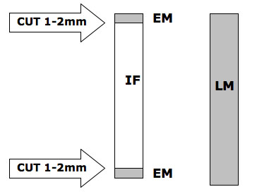
https://medicine.uiowa.edu/uidl/renal-pathology/renal-biopsy-specimen-preparation-transport-instructions
SUPPORTING DOCUMENTATION:

